Setup Instruction – GARECO

Purpose: The purpose of this setup instruction is to provide a procedure for turning on or enabling the optional GARECO interface in an X-series control.
Application: GARECO is an option and requires data out through a serial interface.
Audience: This setup instruction is directed to the manufacturing personnel with administrator access rights to the X-series control.
Required: WiBu key programmed as Admininstrator. X-Series Record Control Sheet or equivalent document. Thumb drive (USB memory stick) for capturing and archiving setup information.
Preparation: Running System
How To

to Enable Statistics in the Feature Control Menu
Use 6J-01N-0069 to enable statistics through XFC

Instruction

1. Feature Control Screen

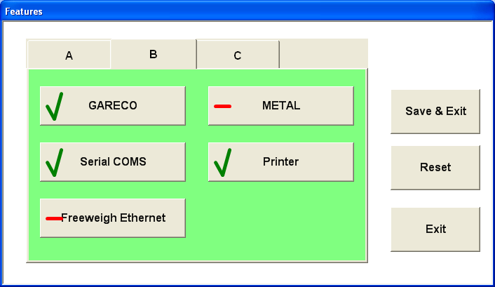

1 | If there is a Red dash in the GARECO block, touch the Red dash. The character changes to a Green Check Mark. |  | A green check in the GARECO block will turn on the GARECO communication program.
2 | Press the ‘Save and Exit’ button and then the ‘Close’ button and the system will restart. |  | Retrun to main user screen

Testing
.
Connect the machine to a Manufacturing PC through the corresponding interface i.e. no modem cable or with Ethernet using a cross-over cable and run the PC terminal emulation program. Make sure the terminal is setup to run you interface. Once the program is up and running send the following commands:

FB_INFO<CRLF>
Will return all the machine information like versions etc

FB_ART_NAMES<CRLF>
Will return a list of all package setup information

If these 2 commands return the expected information without a problem,

6J-01N-0061 Revision History
Rev. | Date | Who | Description
A | 10/1/2007 | E. Inglin | Original

